### **Project 1: Deploying Ansible**

**Problem Statement:** You are tasked with deploying Ansible in a multi-node environment consisting of multiple Linux servers. The goal is to set up Ansible on a control node and configure it to manage several managed nodes. This setup will be used for automating system administration tasks across the network.

**Deliverables:**

1. **Control Node Setup:**
   * Install Ansible on the control node.

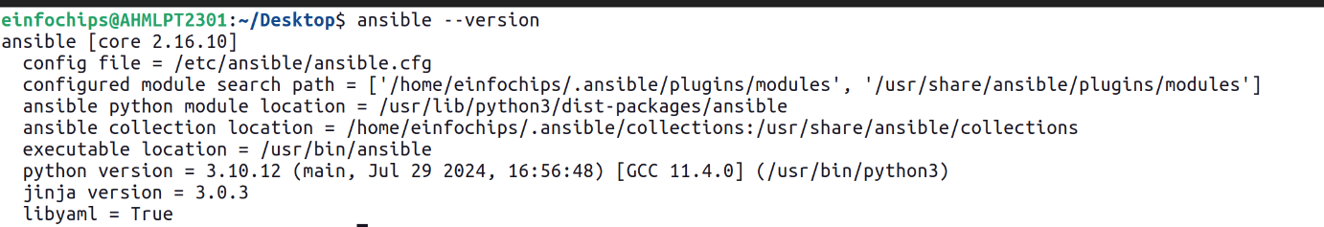

* + Configure SSH key-based authentication between the control node and managed nodes.

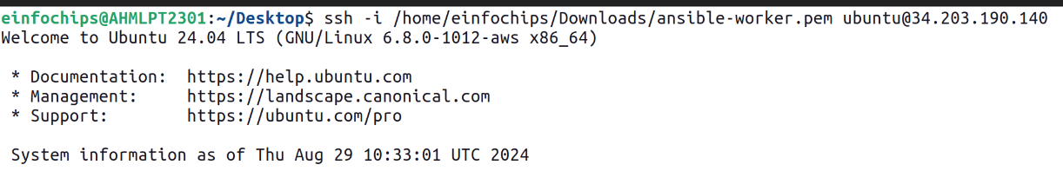

1. **Managed Nodes Configuration:**
   * Ensure all managed nodes are properly configured to be controlled by Ansible.



* + Verify connectivity and proper setup between the control node and managed nodes.

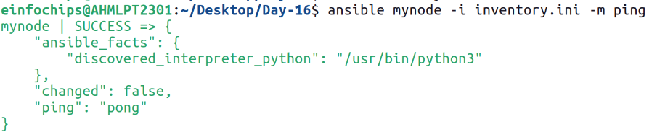

### **Project 2: Ad-Hoc Ansible Commands**

**Problem Statement:** Your organization needs to perform frequent, one-off administrative tasks across a fleet of servers. These tasks include checking disk usage, restarting services, and updating packages. You are required to use Ansible ad-hoc commands to accomplish these tasks efficiently.

**Deliverables:**

1. **Task Execution:**
   * Execute commands to check disk usage across all managed nodes.

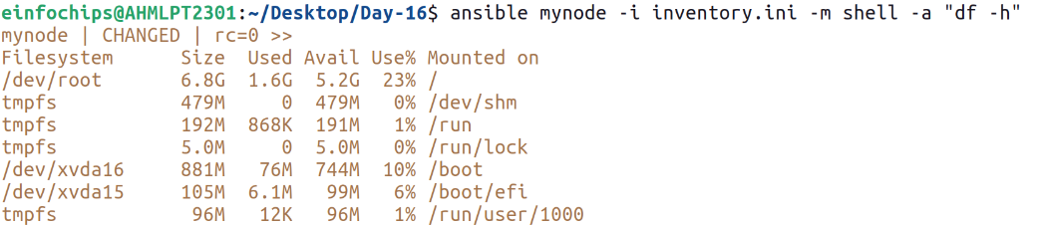

* + Restart a specific service on all managed nodes.

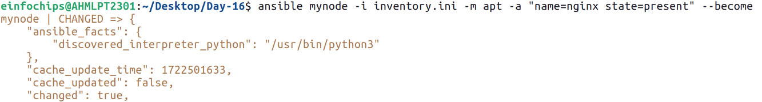

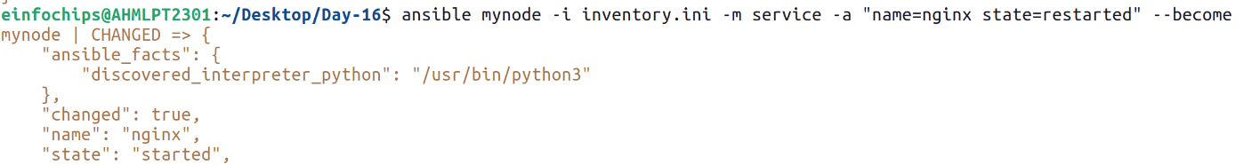

* + Update all packages on a subset of managed nodes.

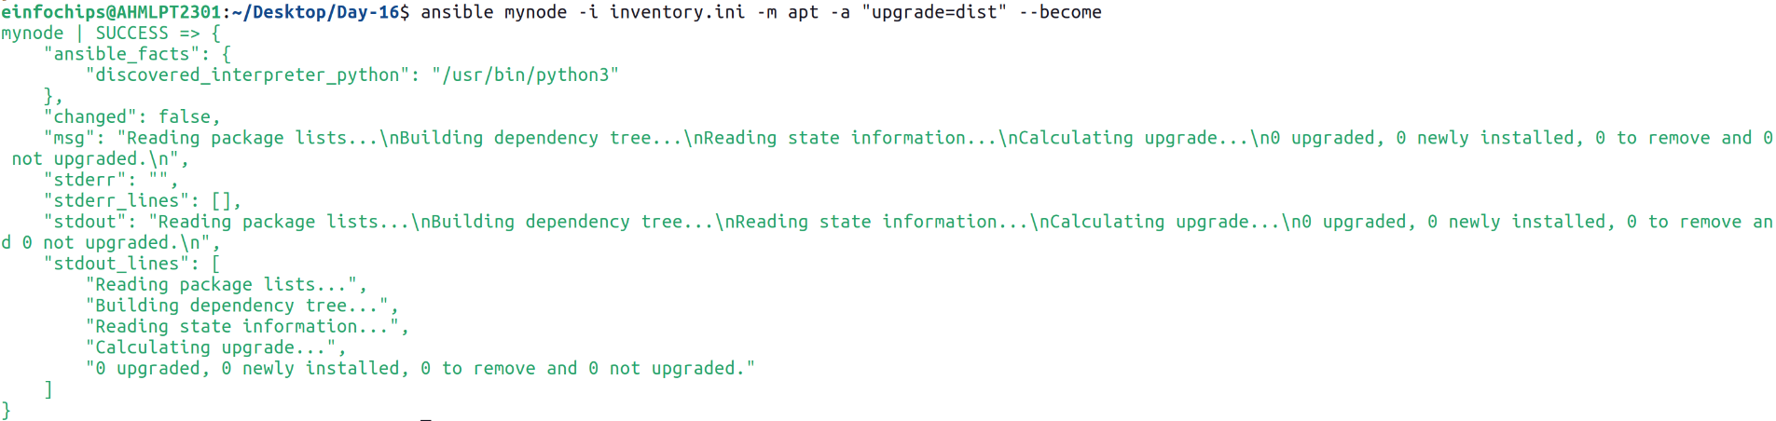

1. **Command Scripts:**

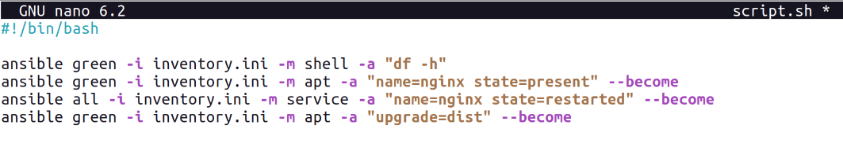

### **Project 3: Working with Ansible Inventories**

**Problem Statement:** You need to manage a dynamic and diverse set of servers, which requires an organized and flexible inventory system. The project involves creating static and dynamic inventories in Ansible to categorize servers based on different attributes such as environment (development, staging, production) and roles (web servers, database servers).

**Deliverables:**

1. **Static Inventory:**



### **Project 4: Ansible Playbooks: The Basics**

**Problem Statement:** Your team needs to automate repetitive tasks such as installing packages, configuring services, and managing files on multiple servers. The project involves writing basic Ansible playbooks to automate these tasks, ensuring consistency and efficiency in the operations.

**Deliverables:**

1. **Playbook Creation:**

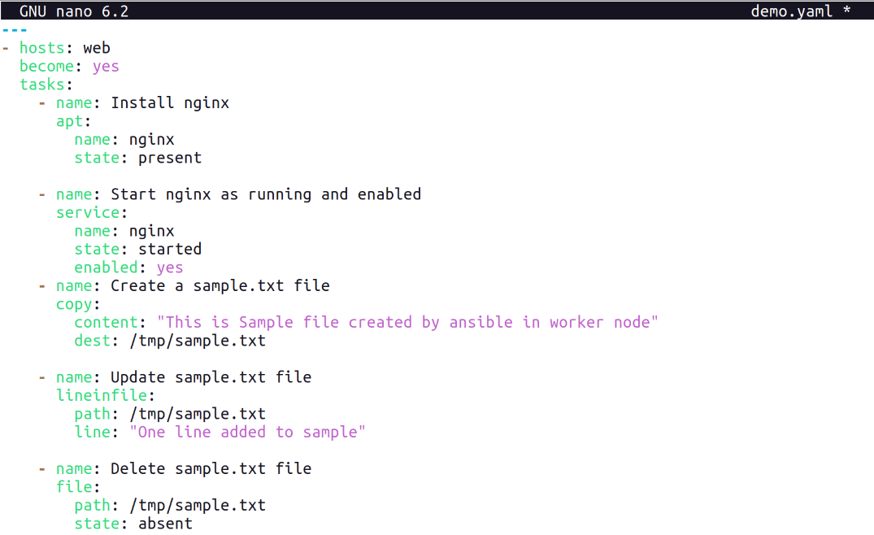

1. **Testing and Verification:**

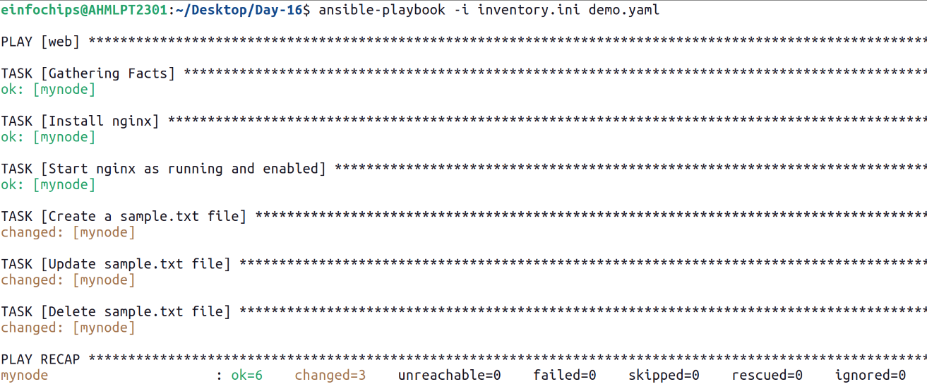

### **Project 5: Ansible Playbooks - Error Handling**

**Problem Statement:** In a complex IT environment, tasks automated by Ansible playbooks may encounter errors due to various reasons such as incorrect configurations, unavailable resources, or network issues. The project focuses on implementing error handling in Ansible playbooks to ensure resilience and proper reporting of issues.

**Deliverables:**

1. **Playbook with Error Handling:**

